Fractional Knapsack

Problem
We are given n items with {weight, value} of each item and the capacity of knapsack (bori) W. We need to put these items in the knapsack such that the final value of items in the knapsack is maximum.

Example
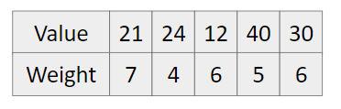
W = 20
Approach (Think greedily)
- Calculate value per unit weight.
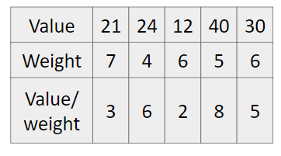
- Sort in decreasing order according to value/weight.
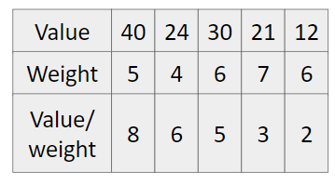
- Pick from the starting till our knapsack has capacity.
So maximum value = 40 + 24 + 30 + 3(5) = 109.

Code
#include<bits/stdc++.h>
using namespace std;
#define int long long

struct item {
double value, weight, valuePerWeight;
};

bool compare(item i1, item i2) {
return i1.valuePerWeight > i2.valuePerWeight;
}

signed main() {
int n; cin >> n;

vector<item> items;
for(int i=0; i<n; i++) {
double v,w;
cin >> v >> w;

items.push_back({v,w,v/w});
}

double W; cin >> W;

sort(items.begin(), items.end(), compare);

int ans = 0;
for(int i=0; i<n; i++) {
if(W >= items[i].weight) {
W -= items[i].weight;
ans += items[i].value;
}
else {
ans += W * items[i].valuePerWeight;
W = 0;
break;
}
}
cout << ans << endl;
return 0;
}

